**Project Design Phase-II**

**Technology Stack (Architecture & Stack)**

|  |  |
| --- | --- |
| Date | 21October 2022 |
| Team ID | PNT2022TMID03607 |
| Project Name | Corporate Employee Attrition Analytics |
| Maximum Marks | 4 Marks |

**Technology Architecture:**

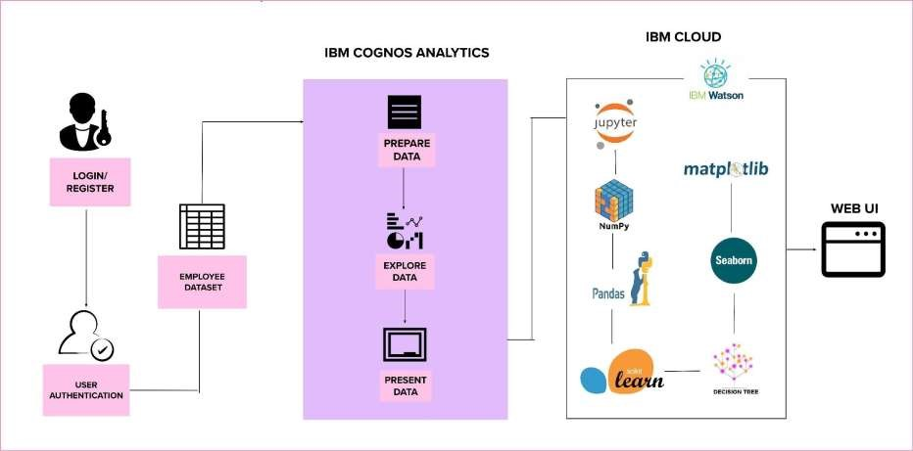

**Table-1: Components & Technologies:**

|  |  |  |  |
| --- | --- | --- | --- |
| **S.No.** | **Characteristics** | **Description** | **Technology** |
| 1. | Open-Source Frameworks | A software for which the original source code made freely available and may be redistributed and modified according to the requirements of user. | Python, Google Colab/ Jupyter |
| 2. | Security Implementations | IBM Cloud Application provides security features that are in addition to many of the components identified in the security framework. | IBM Cloud Pak for Security |

|  |  |  |  |
| --- | --- | --- | --- |
| **S.No.** | **Component** | **Description** | **Technology** |
| 1. | User Interface | User interacts with the application using IBM Cloud, which is used to analyze the dataset. | IBM Cloud |
| 2. | Application Logic | The logic is to obtain useful insights about the corporate employee attrition of the organization. | Python |
| 3. | Dataset | It contains the details about the employee attrition. | “HR Analytics Case Study” dataset from  Kaggle |
| 4. | Cloud Database | It is used to store all the datasets from Kaggle. | IBM Cloud Pak for Data |
| 5. | Visualization | It is used to prepare, explore and present the data in the form of charts and graphs. | IBM Cognos Analytics |
| 6. | Machine Learning Model | It allows the user to feed a computer algorithm, an immense amount of data and have the computer analyse and make data-driven recommendation and decision based on only the input data. | Model for employee attrition |
| 7. | Infrastructure | It provides the platform for deployment and services. | Kubernetes |

**Table-2: Application Characteristics:**

|  |  |  |  |
| --- | --- | --- | --- |
| **S.No.** | **Characteristics** | **Description** | **Technology** |
| 3. | Scalable Architecture | Python is a programming language that developers can use to do all the scaling work. To improve scalability, enable or disable server run by HR to balance the load for a given computer by request type. | Python, IBM Cognos |
| 4. | Availability | Availability is the ability of a system to withstand or recover from exceptional situation. The Google Colab/ Jupyter is interactive computing platform. It can support coding, visualisation, etc. | Google Colab/ Jupyter |
| 5. | Performance | This is a fundamental step if we need to achieve the greatest benefit with the least amount of work. Designing for capacity means determining the hardware needed for your system to perform well under its workload. | Python |